

**Chic Lighting & Design**

|  |  |  |
| --- | --- | --- |
| **Supervisor:** | *LÊ THANH NHÂN* | |
| **Semester:** | *01* | |
| **Batch No:** | *T1.2210.E1* | |
| **Group No:** | *04* | |
| **Order:** | **Full name** | **Roll No.** |
| *1.* | *Đặng Vặn Sang* | *Student1429111* |
| *2.* | *Nguyễn Minh Khang* | *Student1429115* |
| *3.* | *Trần Quốc Khánh* | *Student1424189* |
| *4* | *Trần Anh Tiến* | *Student1429120* |

***Month****: 02* ***Year****: 2023*



This is to certify that

|  |  |
| --- | --- |
| **Mr.** | **ĐẶNG VĂN SANG** |
| **Mr.** | **NGUYỄN MINH KHANG** |
| **Mr.** | **TRẦN QUỐC KHÁNH** |
| **Mr.** | **TRẦN ANH TIẾN** |

Have successfully Designed & Developed

|  |  |  |
| --- | --- | --- |
|  |  |  |
| **CHIC LIGHTING & DESIGN** | | |

Submitted by:

|  |
| --- |
| **Mr. LE THANH NHAN** |

Date Of Issue:

|  |  |
| --- | --- |
|  |  |

Authorized Signature:

|  |  |
| --- | --- |
|  |  |

|  |
| --- |
| **Content** |

Content

Acknowledge

Synposis

Review1 (điền số trang theo thực tế)

Review2 (điền số trang theo thực tế)

Review3 (điền số trang theo thực tế)

Testting Document (điền số trang theo thực tế)

Final Checklist (điền số trang theo thực tế)

Tasksheet (điền số trang theo thực tế)

|  |
| --- |
| **Acknowledge** |

As we understand that the eProject is a step-by- step learning environment that closely simulates the class-room and Lab based learning environment into actual implementation. It is a project implementation at your fingertips!! An electronic, live juncture on the machine that allows you to.

* Practice step by step i.e. laddered approach.
* Build a larger more robust application.
* Usage of certain utilities in applications designed by user.
* Single program to unified code leading to a complete application.
* Learn implementation of concepts in a phased manner.
* Enhance skills and add value.
* Work on real life projects.
* Give a real life scenario and help to create applications more complicated and useful.
* Mentoring through email support.

We would like to send a great thank to our professor and others student for the addorable supports during the time in project. We hope to have more oppotunities to widen our knownledge in web developing world.

We also thank you so much for your infomation and the “demo” project from India APTECH to help us get more reality experience in this project. We will not stop learning to be more successful in the future.

Your Sincerely,

Team Group 04.

|  |
| --- |
| **Synposis** |

The Objective of this program we aim is to give a sample project to work on real life projects. These applications help us build a larger more robust application.

The objective is not to teach us JSON/JavaScript/Dreamweaver/HTML5 but to provide us with a real life scenario and help us create basic applications using the tools.

Therefore, we can revise the chapters before we start with the project.

This project is meant for students like us who have completed the module of HTML5. These programs should be done in the Lab sessions with assistance of the faculty if required.

It is very essential for us that will have a clear understanding of the subject. We think we should go through the project and solve the assignments as per requirements given.

|  |
| --- |
| **Problem Definition** |

Chic Lighting & Design has its presence since 1971. We offer unique lighting and accessories from the most elegant traditional to refined contemporary for today’s eclectic interiors.

Chic Lighting & Design is an online retailer that specializes in LED Lights, Lamps, Chandeliers and Pendant lighting. We have a range of collections that include; crystal chandeliers, traditional chandeliers, modern chandeliers, glass pendant lights, industrial and retro pendant lights, metal pendant lights and many more.

At Chic Lighting & Design, we are dedicated to customer service. When you call or email during normal business hours, you will speak or get reply from a design professional. Our knowledgeable and experienced staff receives ongoing education and training and is available to assist with all of your lighting projects.

You are supposed to create a Single-Page-Application and responsive Website for them with the below mentioned requirement specifications.

The website is to be developed for the Windows Platform using HTML5, JSON, Angular JS, JavaScript and Geolocation. The site should work well in all leading browsers including Chrome, IE, Firefox etc.

**Functional Requirement Specification:**

The portal will be designed as a Single-Page-Application and responsive Website with a set of pages and menus that represent choice of activities to be performed. The pages, menus, and other visual elements must be designed in a visually appealing manner with attractive fonts, colors, and animations.

All of these should also be laid out in a responsive manner

The Web site is to be created based on the following requirements.

1. The Top of the Page should be presented with a suitable logo and images of Lights & Chandeliers.
2. The site must contain the various sections such as CEILING LIGHTS, WALL LIGHTS, LAMPS, OUTDOOR LIGHTS, FANS and HOME ACCENTS etc.
3. Section on LED Lights should be provided with various products listed such as Spot Lights, Decoration Lights, Smart Lights etc.
4. Specification and Pricing of Lights should be added along with the images.
5. A menu on the Top with all sections listed should be provided.
6. Website should provide section filter for various brands offered in the store.
7. Gallery section should be added for viewing different images.
8. Feedback must be allowed to enter by the viewer
9. Site map, Gallery, About us, FAQ link, Contact us must be added.
10. The complete description must be allowed to get download as pdf or doc file.
11. Section for various offers in the store should be provided with listing of offers with details.

Over and above this, the portal should implement the following functionalities:

* Display a continuous scrolling ticker at the bottom of the page with current date, time, and location (hint: Use geolocation features of HTML5).
* Display a visitor count at the top right corner of the page beside a logo image.
* The menu options should change color on hover and also after clicking.
* Fade in and fade out options can be used for the menus.

|  |  |  |  |  |  |  |  |  |  |  |  |  |  |  |  |
| --- | --- | --- | --- | --- | --- | --- | --- | --- | --- | --- | --- | --- | --- | --- | --- |
| |  | | --- | | **Customer Requirements Specifications** |   Mô tả các điểm trong chu trình xử lý dữ liệu cho từng đối tượng sử dụng.   |  |  | | --- | --- | | **User:** | | |  | **input:** | |  | * Nhập dữ liệu 01 * Nhập dữ liệu 02 * Nhập dữ liệu 03 | |  | **Process:** | |  | * Xử lý dữ liệu 01 * Xử lý dữ liệu 02 * Xử lý dữ liệu 03 | |  | **Output:** | |  | * Xuất thông tin 01 * Xuất thông tin 02 * Xuất thông tin 03 | |

|  |  |
| --- | --- |
| **Webmaster:** | |
|  | **input:** |
|  | * Nhập dữ liệu 01 * Nhập dữ liệu 02 * Nhập dữ liệu 03 |
|  | **Process:** |
|  | * Xử lý dữ liệu 01 * Xử lý dữ liệu 02 * Xử lý dữ liệu 03 |
|  | **Output:** |
|  | * Xuất thông tin 01 * Xuất thông tin 02 * Xuất thông tin 03 |

|  |  |
| --- | --- |
| **Hardware / software requirement:** | |
|  | **Software:** |
|  | Technologies to be used:   * Frontend: HTML5, CSS, Bootstrap, JavaScript, jQuery, AngularJS, XML * Data Store: JSON files or TXT files |
|  | **Hardware:** |
|  | * Intel Core i3/i5 Processor or higher * 8 GB RAM or above * Color SVGA * 500 GB Hard Disk space * Mouse * Keyboard |

|  |
| --- |
| **Architecture and design of the project** |

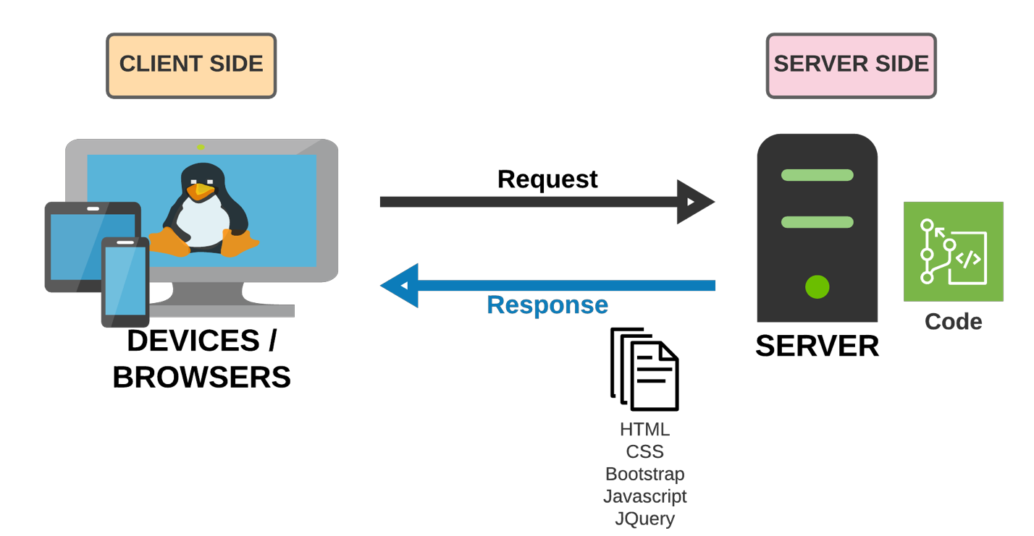

|  |
| --- |
| **SiteMap** |

1. Sơ đồ trang của project.
2. Xem Problem Statement trong đề tài của India
3. Từ Home, vẽ các menu chính thành cấp F1.
4. Bổ sung thêm cấp F2.

|  |
| --- |
| **Screen shots** |

Các layout mô tả màn hình. Sinh viên có thể vẽ layout. Nếu không thể thì code HTML cơ bản rồi chụp lại hình màn hình.

**Ví dụ cách thứ nhất:** (Khuyến cáo sử dụng)

1. **Homepage:**

|  |  |  |  |  |  |
| --- | --- | --- | --- | --- | --- |
| Logo | | | Banner size x size | | Banner size x size |
| Homepage | Categories | | Register | | About us |
| < | | Services Carousel | | > | |
| Enter text for searching:  Click for seaching | | | | | |
|  | | | | | |
| Footer | | | | | |

**Description** : Mô tả màn hình là gì? Dùng làm gì?

**From** : Được mở từ đâu? Menu nào?

**To** : Có thể tới được trang nào khác?

**Ví dụ cách thứ hai:**

1. **Homepage:**

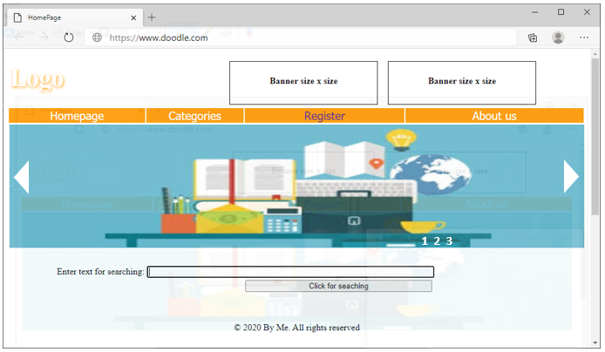

**Description** : Mô tả màn hình là gì? Dùng làm gì?

**From** : Được mở từ đâu? Menu nào?

**To** : Có thể tới được trang nào khác?

|  |
| --- |
| **Testing document** |

|  |  |  |
| --- | --- | --- |
| **Sr.No** | **Features Tested** | **Remarks** |
| 1 |  |  |
| 2 |  |  |
| 3 |  |  |
| 4 |  |  |
| 5 |  |  |
| 6 |  |  |
| 7 |  |  |
| 8 |  |  |
| 9 |  |  |
| 10 |  |  |
| 11 |  |  |
| 12 |  |  |
| 13 |  |  |
| 14 |  |  |
| 15 |  |  |

|  |
| --- |
| **Final checklist** |

|  |  |  |
| --- | --- | --- |
| **Sr.No** | **Aspected Tested** | **Suggestion/**  **Remarks** |
| 1 | Are all the users able to view the images and links? |  |
| 2 | Have all the views, modules and controllers been properly integrated and is the site function as a single page application? |  |
| 3 | Are the GUI content devoid of spelling mistakes? |  |
| 4 | Is the application user-friendly? |  |
| 5 | Is the Website launching correctly in all popular browsers? |  |
| 6 | Are all the forms validated with proper criteria? |  |
| 7 | Do all text links lead to the appropriate website? |  |
| 8 | Do all image links lead to the appropriate website? |  |
| 9 | Are all the images and links clearly visible on the page? |  |
| 10 | Does the Web page work properly in all the tested browsers? |  |
| 11 | Does the Web page take too long to be loaded fully? |  |
| 12 | Is the navigation sequences correct through all the Web pages on the site? |  |
| 13 | Is the JavaScript code working as expected in all click events? |  |
|  |  |  |
|  | (Sinh viên ghi thêm…) |  |

|  |  |  |  |  |  |  |  |  |  |  |  |
| --- | --- | --- | --- | --- | --- | --- | --- | --- | --- | --- | --- |
|  | **Member** | | **Contents** | | **Page Name** | **Activity Plan** | **Date of Preparation of Activity Plan** | | | | |
| **Planed Start Date** | **Actual Start Date** | **Actual Days** | | **Status** | |
| 1 | Đặng Văn Sang | | Home | | Home.html | 14-01-2023 | 15-01-2023 |  | |  | |
| 2 | Sign In | | SignIn.html | 14-01-2023 | 15-01-2023 |  | |  | |
|  | | | | | | | | | | | |
| 1 | Nguyễn Minh Khang | | Contact Us | | ContactUs.html | 14-01-2023 | 16-01-2023 |  | |  | |
| 2 | About Us | | AboutUs.html | 14-01-2023 | 16-01-2023 |  | |  | |
|  | | | | | | | | | | | |
|  | | Trần Quốc Khánh | Product | Product.html | | 14-01-2023 | 17-01-2023 | |  | |  |
|  | | 14-01-2023 |  | |  |
|  | | | | | | | | | | | |
| 1 | Trần Anh Tiến | | Product | | Product.html | 14-01-2023 | 18-01-2023 |  | |  | |
| 2 | 14-01-2023 |  | |  | |